Test # | Description | PASS/FAIL
1 | Start button | PASS
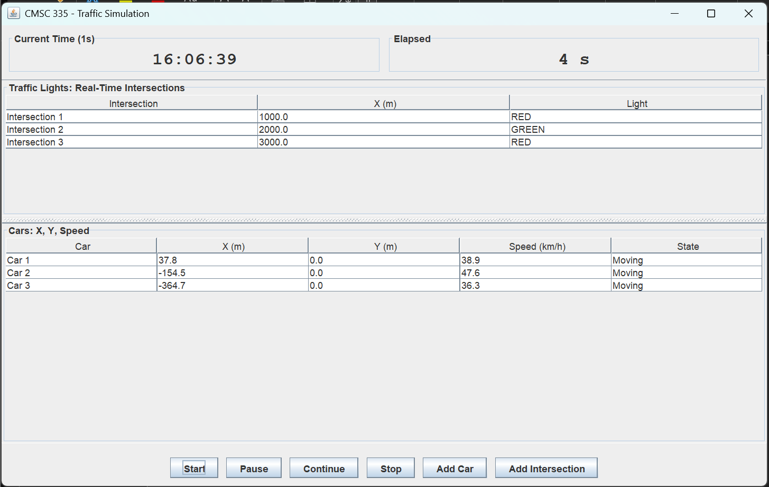
Test # | Description | PASS/FAIL
2 | Pause button | PASS
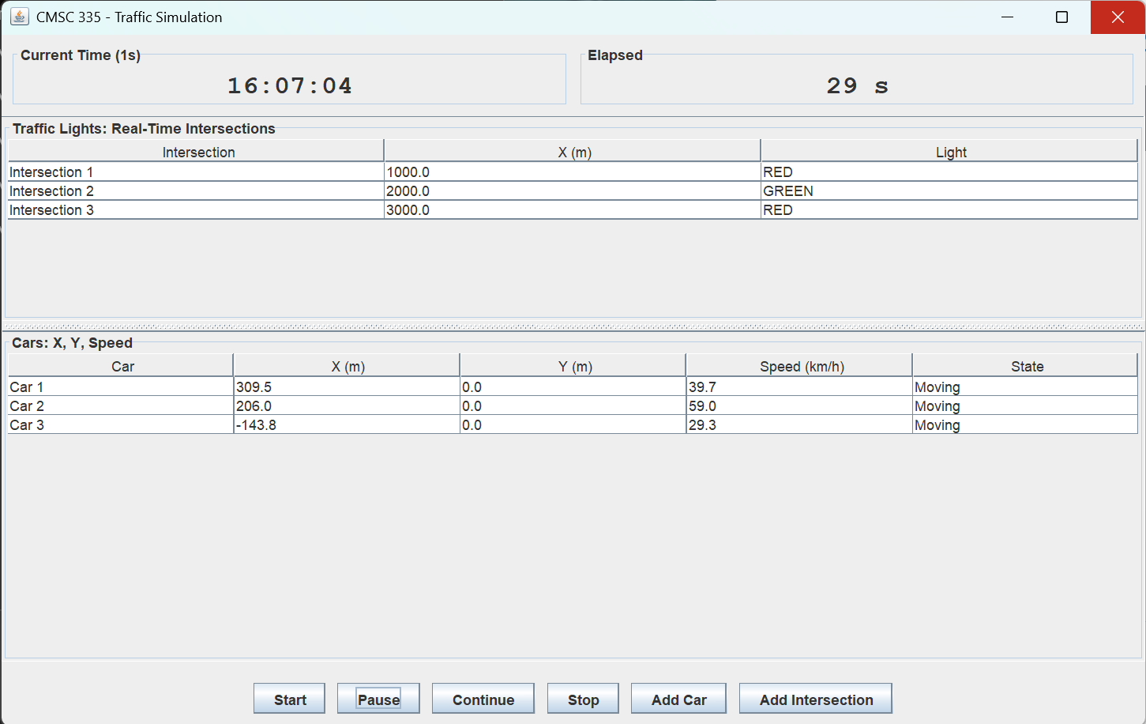

Test # | Description | PASS/FAIL
3 | Continue button | PASS
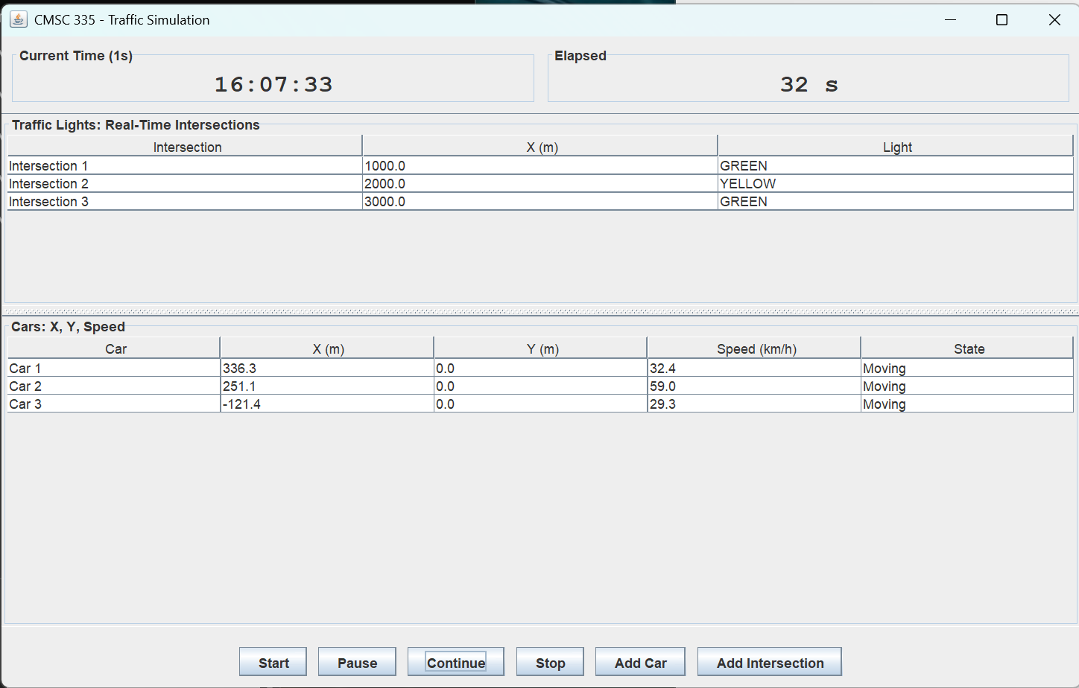
Test # | Description | PASS/FAIL
4 | Stop button | PASS
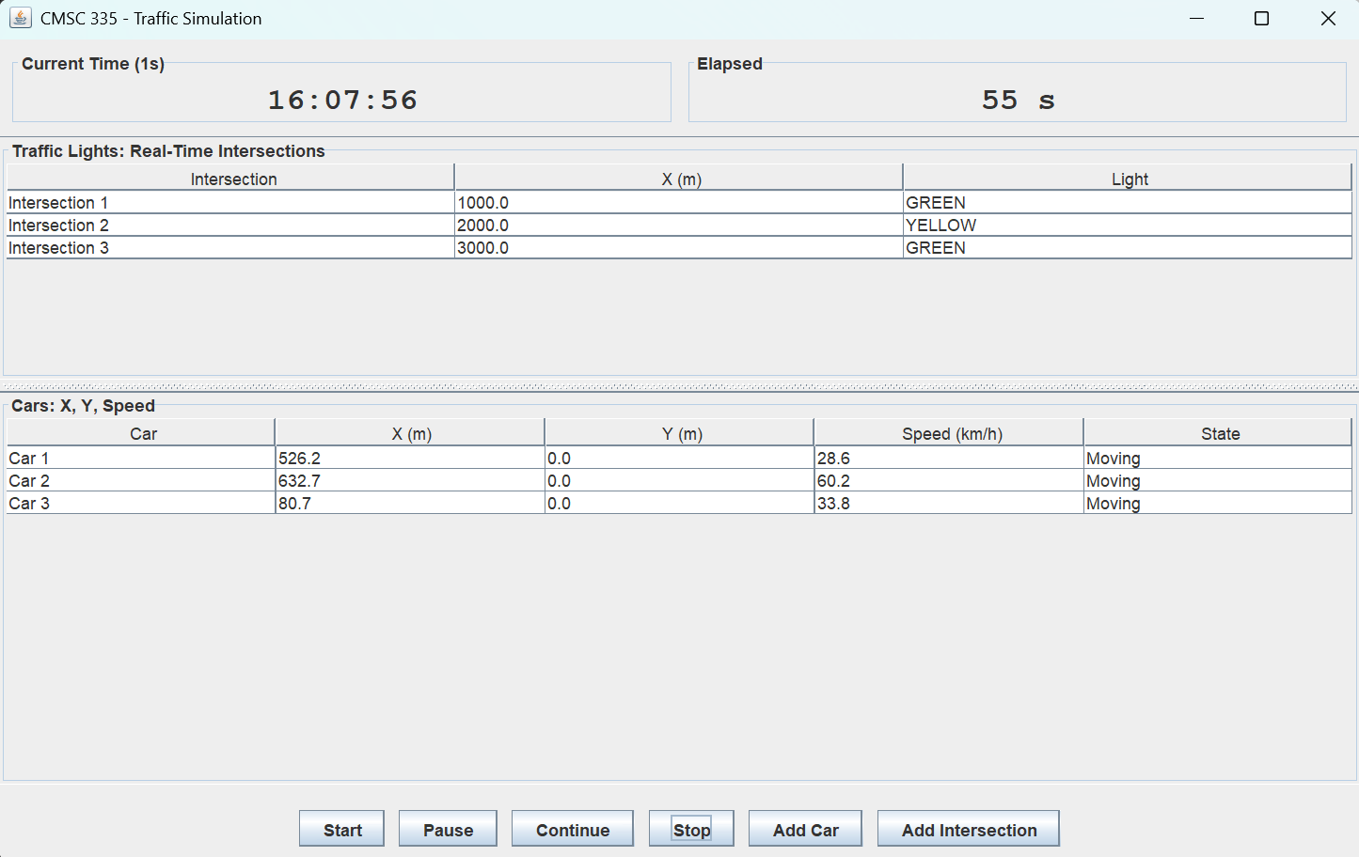
Test # | Description | PASS/FAIL
5 | Three intersections | PASS
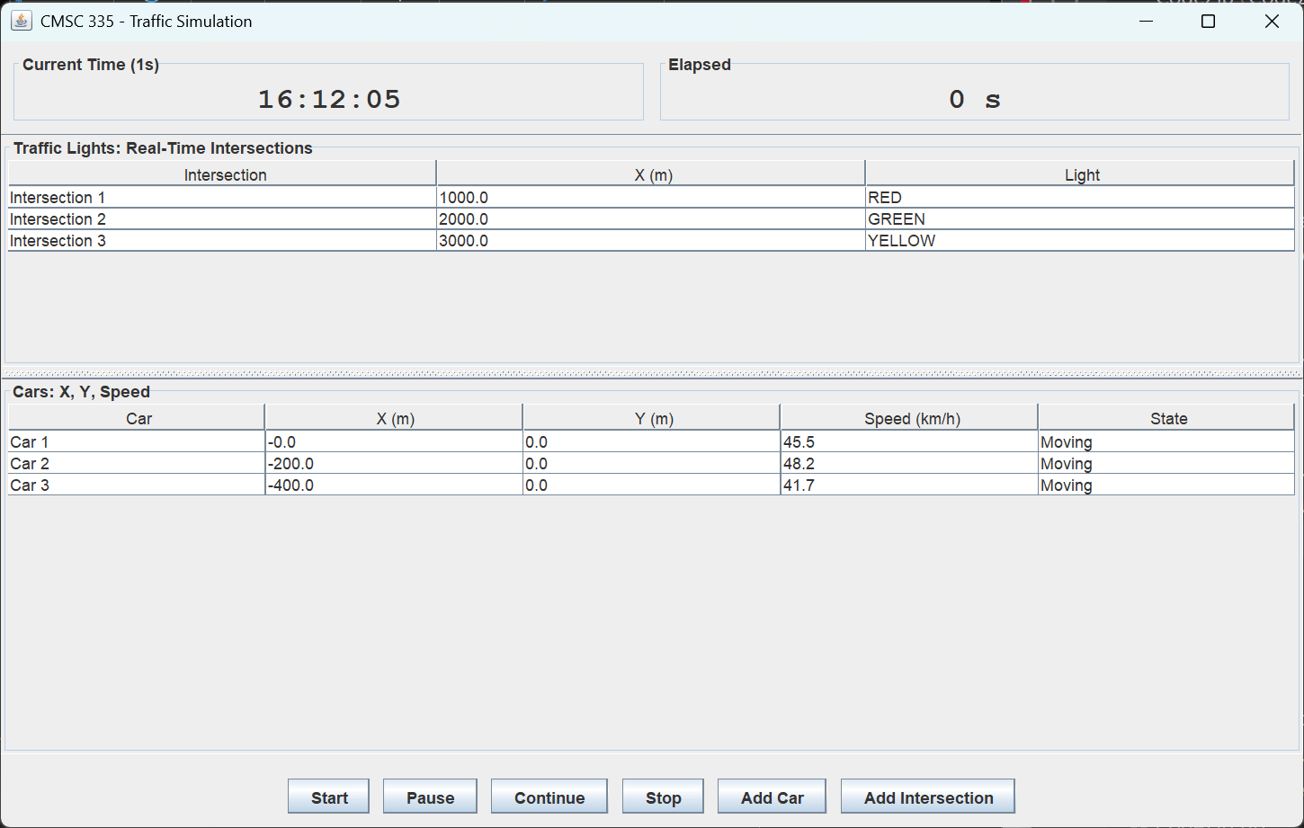
Test # | Description | PASS/FAIL
6 | Car data test (X,Y,speed) | PASS


Test # | Description | PASS/FAIL
7 | Add Car GUI test | PASS
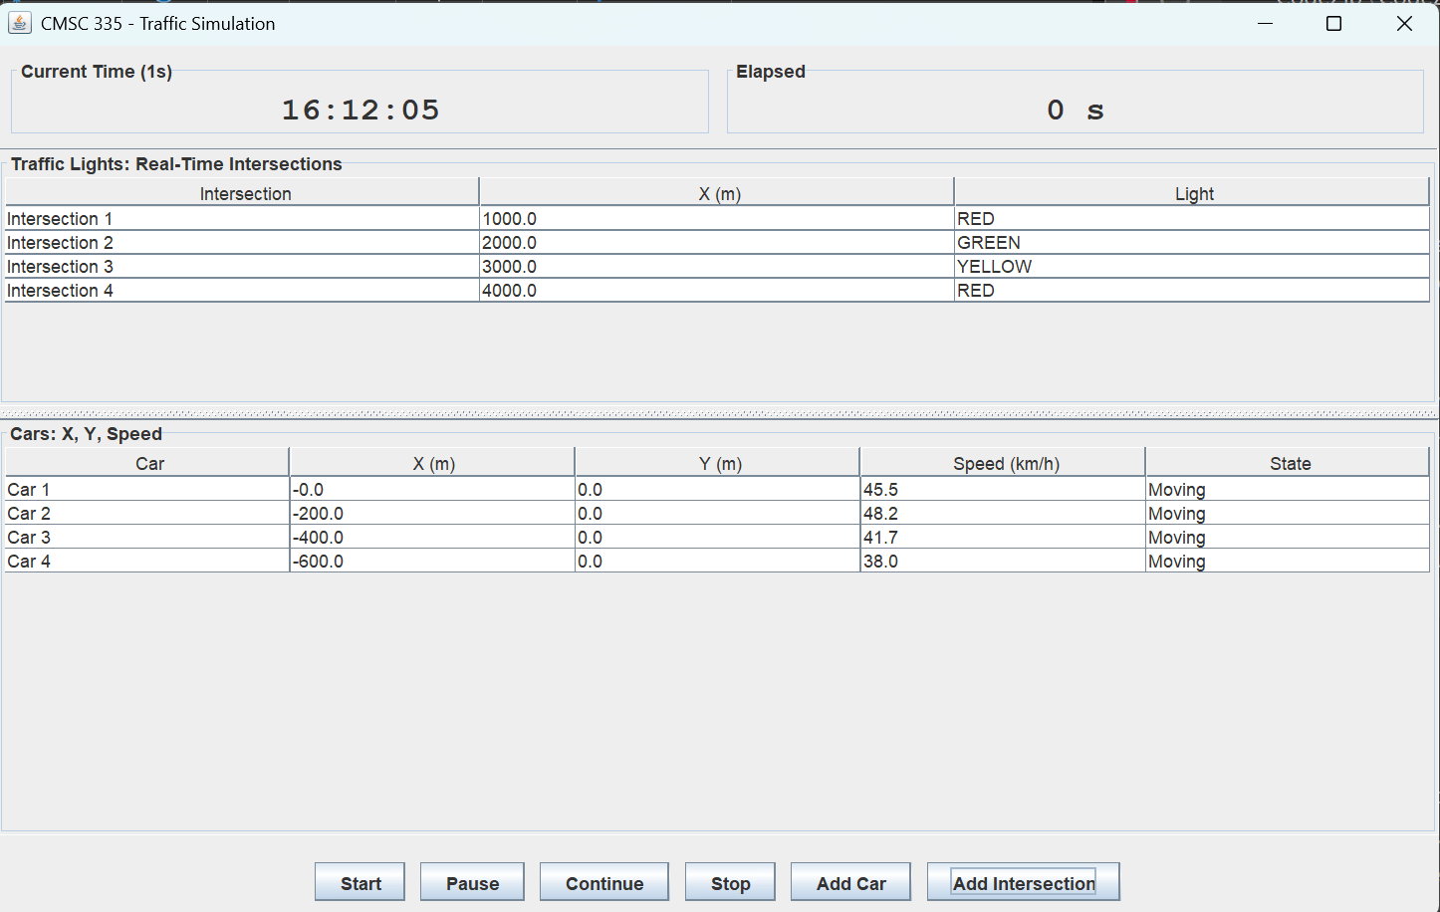

Test # | Description | PASS/FAIL
8 | Add Intersection GUI test | PASS


UML Diagram
